HOMEWORK 5
- Question:
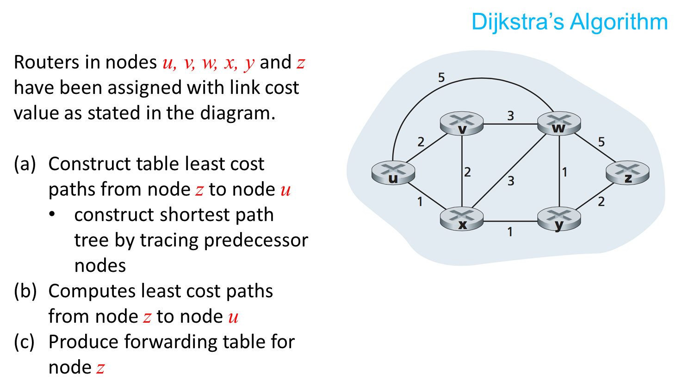
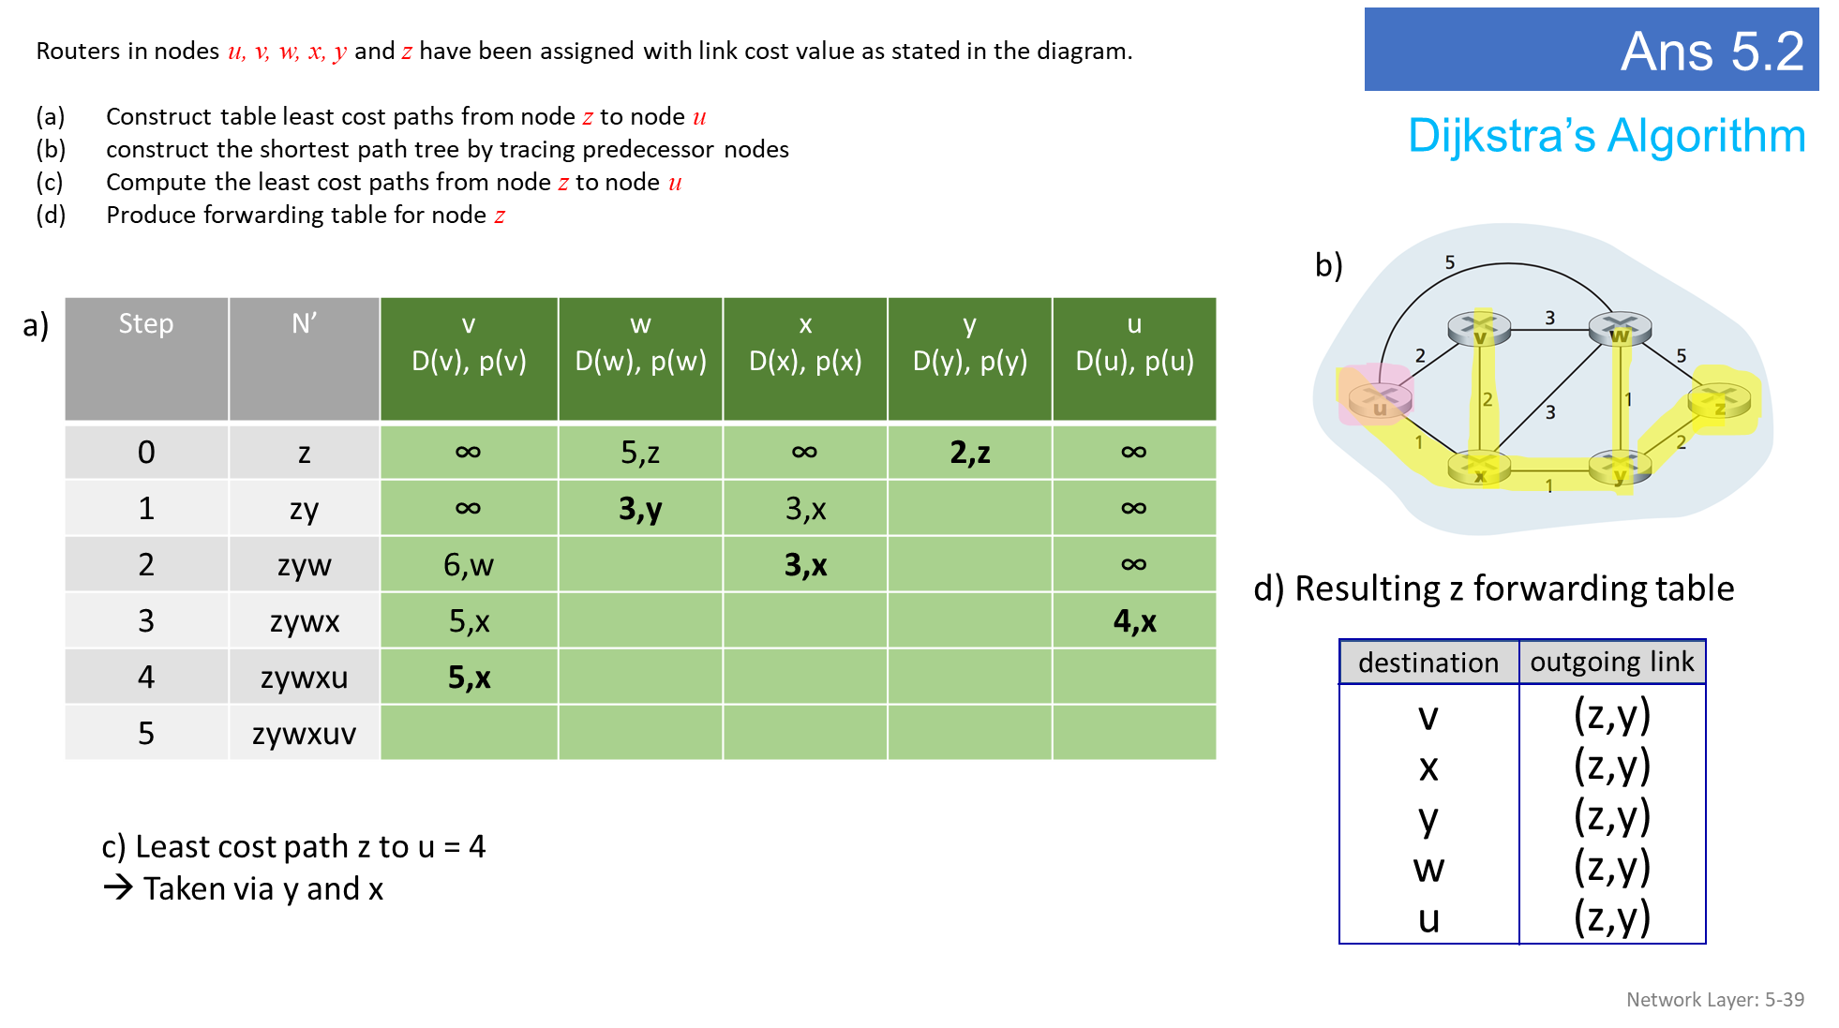
- Question:
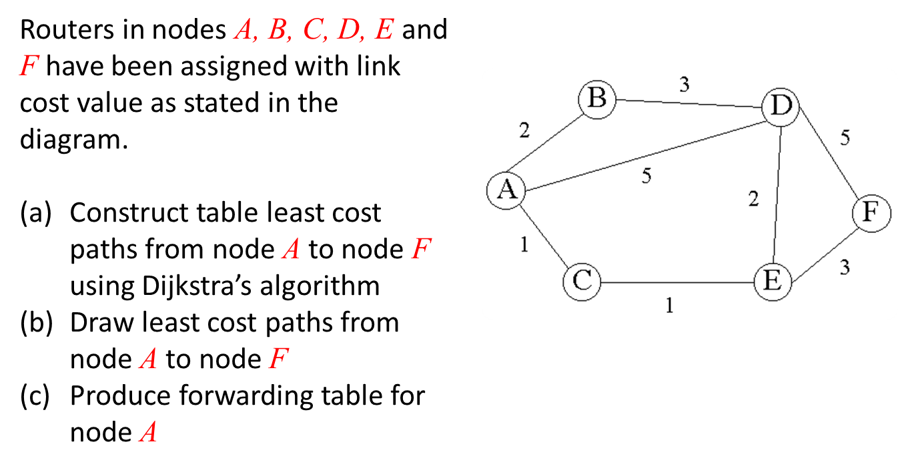
ANS:
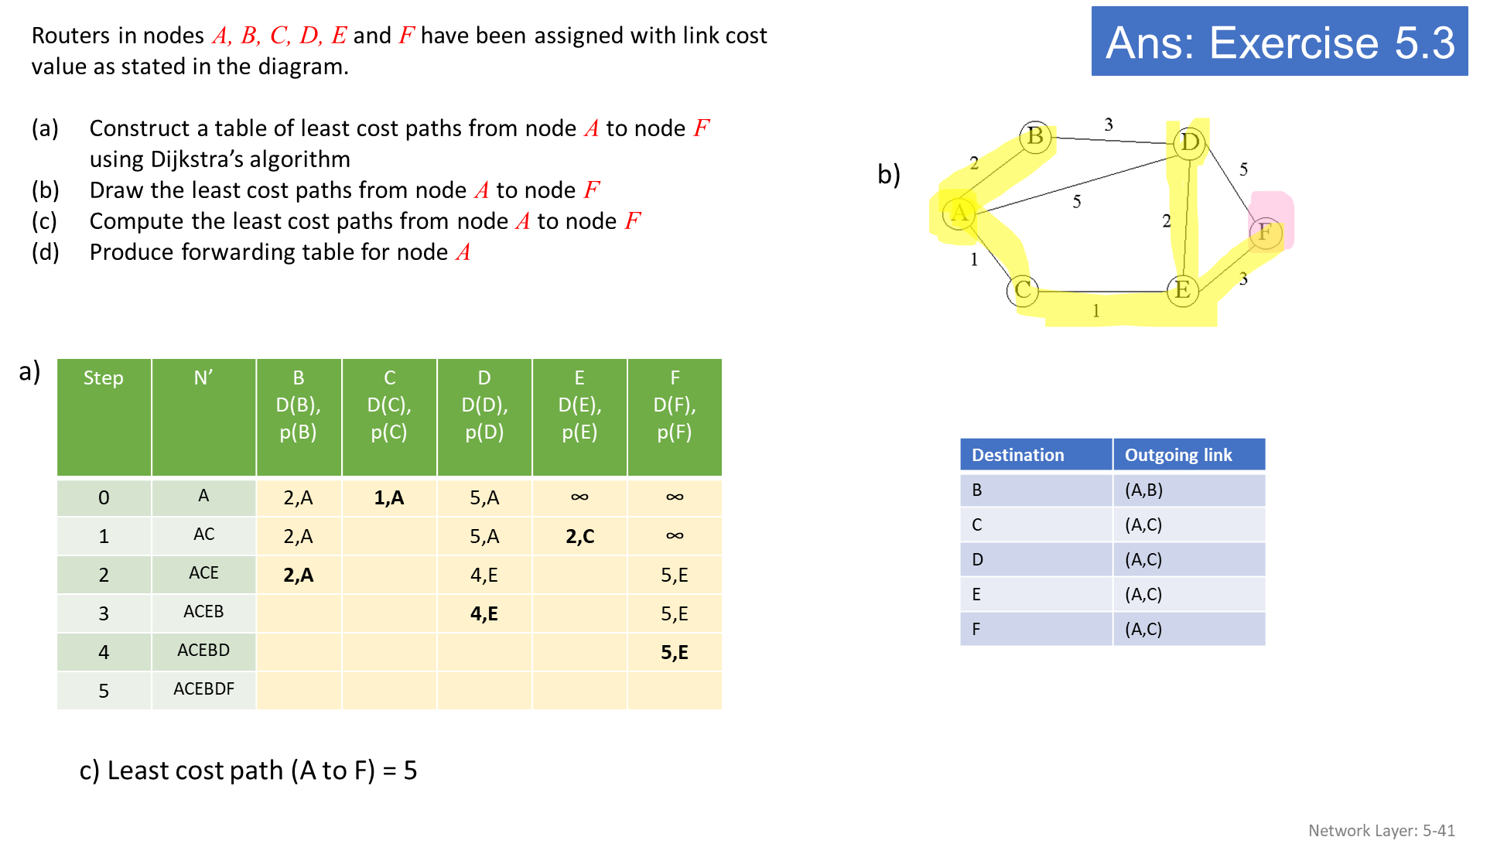
- Question

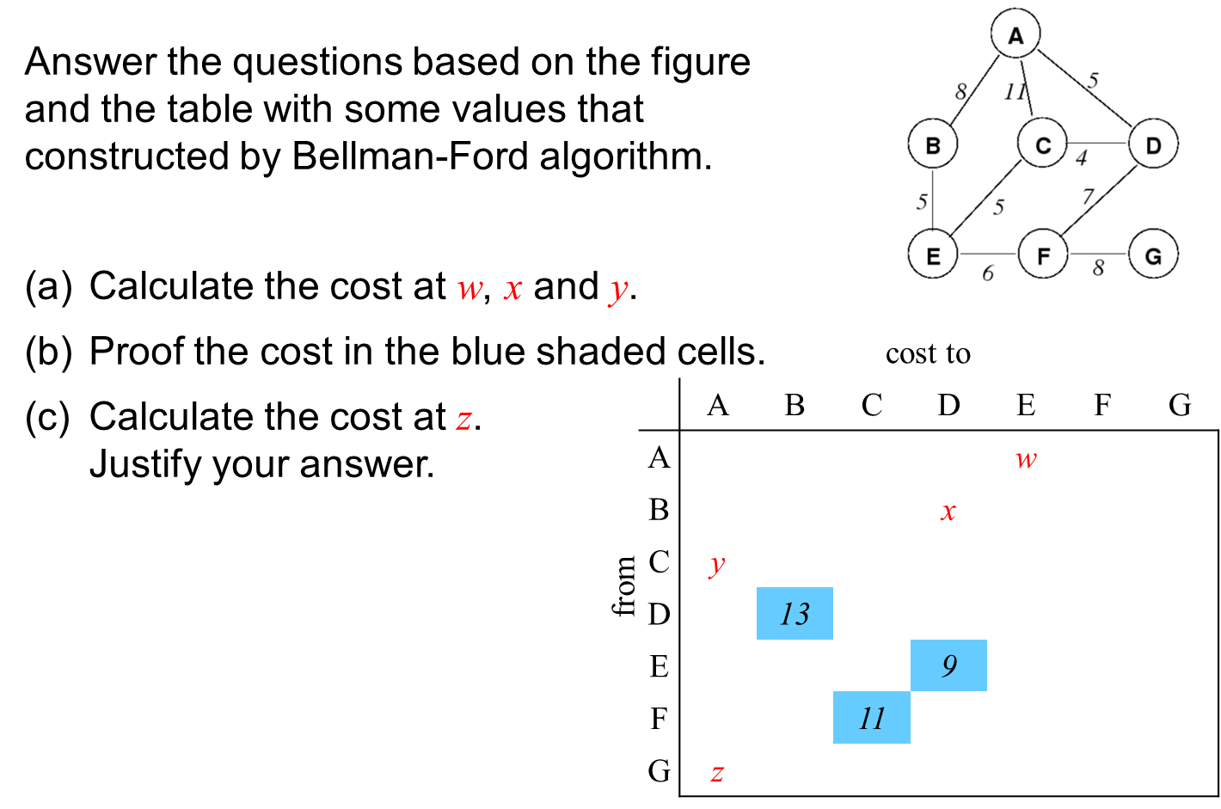
Ans:
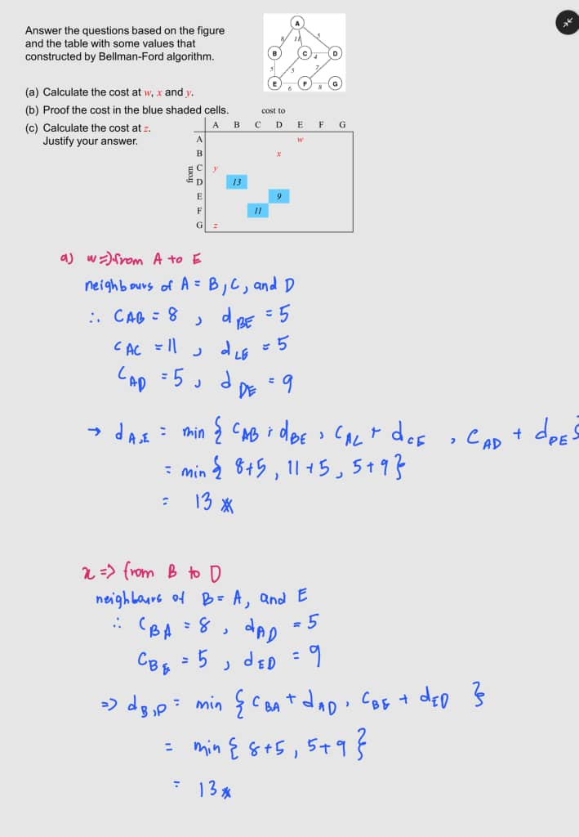
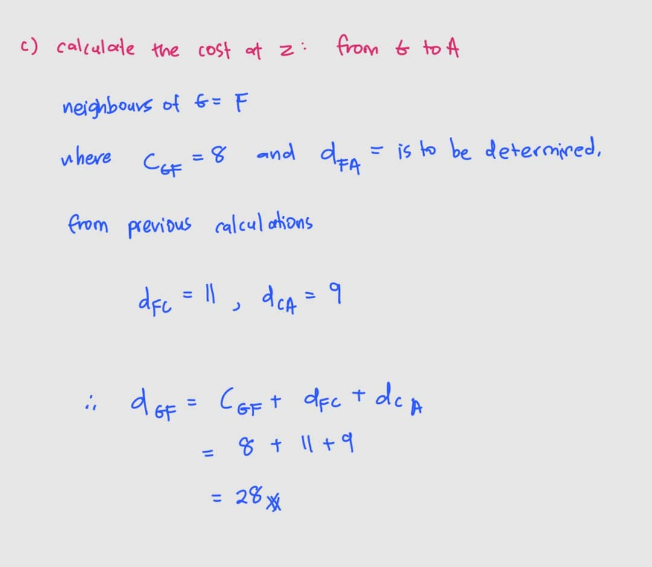
- Question:
Explain the difference between the northbound API and the southbound API in an SDN controller. How do these interfaces contribute to the controller's functionality?
- The northbound API is used for communication between the SDN controller and applications or management systems. It allows applications to query the network state and send directives to the controller to implement specific policies or functionalities.
- The southbound API enables communication between the SDN controller and the network devices (e.g., switches, routers). It is used to configure devices, monitor their state, and implement forwarding rules.
These interfaces ensure separation of concerns:
- The northbound API abstracts network complexity for applications.
- The southbound API provides detailed control over the physical and virtual network infrastructure.
- Question:
What types of messages flow across an SDN controller’s northbound and southbound APIs? Who is the recipient of these messages sent from the controller across the southbound interface, and who sends messages to the controller across the northbound interface?

- Northbound API:
- Message Types: Policy directives, queries about the network state, and application-specific commands.
- Sender: Applications or management systems.
- Recipient: SDN controller.

- Southbound API:
- Message Types:
  - From Controller: Configuration commands (e.g., flow table updates) and device control instructions.
  - To Controller: Device status updates, event notifications (e.g., Packet-In messages), and statistics.
- Sender:
  - To Controller: Network devices (e.g., switches, routers).
  - From Controller: SDN controller.
- Recipient:
  - Messages sent from the controller are received by network devices.
  - Messages sent to the controller come from network devices.

- Question:
Name four different types of ICMP messages.
- Echo Request (Type 8): Used by the Ping utility to test network connectivity between devices.
- Echo Reply (Type 0): Sent in response to an Echo Request, indicating that the destination is reachable.
- Destination Unreachable (Type 3): Indicates that a destination is unreachable for reasons such as no route, prohibited communication, or network failure.
- Time Exceeded (Type 11): Indicates that a packet's TTL (Time-To-Live) value has expired, typically used by Traceroute to identify intermediate routers.
- Question:
What two types of ICMP messages are received at the sending host executing the Traceroute program?
- Time Exceeded (Type 11): Received when a packet's TTL expires at an intermediate router. This allows Traceroute to identify the router at that hop.
- Destination Unreachable (Type 3): Received when the destination host or network is unreachable, signaling the end of the Traceroute process.
- Question:
Define the following terms in the context of SNMP:
- Managing Server: A centralized system responsible for monitoring and managing network devices using SNMP commands. Often referred to as the SNMP manager.
- Managed Device: A network device (e.g., router, switch, or server) that is monitored and controlled by the managing server. Each device contains an SNMP agent.
- Network Management Agent: A software module running on a managed device that communicates with the managing server to provide status information and execute commands.
- MIB (Management Information Base): A structured database of information about the managed device's resources and performance, accessed by the SNMP manager through the agent.
- Question:
What are the purposes of the SNMP GetRequest and SetRequest messages?
- GetRequest: Used by the managing server to query specific information from a managed device. For example, it can retrieve metrics such as CPU utilization or interface status.
- SetRequest: Used by the managing server to configure or modify parameters on a managed device. For example, it can change a device's IP address or enable/disable an interface.
- Question:
Case study: In a network with four SDN-controlled switches (S1, S2, S3, and S4), where the SDN controller uses Dijkstra's algorithm to compute shortest-path routes, a link failure occurs between S1 and S2. Explain the steps performed by the SDN controller and the switches to detect the failure, update the routing paths, and modify the flow tables to maintain network connectivity, assuming OpenFlow is used for communication between the control plane and the switches.
Solution:
- Switch s1, experiencing a link failure between itself and s2, notifies the SDN
controller of the link-state change using the OpenFlow port-status message.
- The SDN controller receives the OpenFlow message indicating the link-state
change, and notifies the link-state manager, which updates a link-state database.
- The network-control application that implements Dijkstra’s link-state routing
has previously registered to be notified when link state changes. That application receives the notification of the link-state change.
- The link-state routing application interacts with the link-state manager to get
updated link state; it might also consult other components in the state- management
layer. It then computes the new least-cost paths.
- The link-state routing application then interacts with the flow table manager,
which determines the flow tables to be updated.
- The flow table manager then uses the OpenFlow protocol to update flow table
entries at affected switches—s1 (which will now route packets destined to s2 via s4),
s2 (which will now begin receiving packets from s1 via intermediate switch s4), and
s4 (which must now forward packets from s1 destined to s2).

